SHIELD
Experimental Validation of On-Chain Outcome Enforcement
Thesis / Technical Evidence Chapter
Version: October 2026
Status: Prototype validation / Pre-MVP

1. Purpose of the Experiment
This experimental section evaluates whether the SHIELD prototype can enforce a deterministic minimum-output policy at the smart-account execution boundary. The experiment focuses on a narrow claim: when an autonomous agent attempts an approved swap, SHIELD should allow an outcome that satisfies the policy and revert an outcome that falls below the policy threshold.
This experiment does not establish that SHIELD is secure in general, profitable, MEV-resistant, or production-ready. It demonstrates feasibility of the tested enforcement mechanism under the stated local prototype conditions.

2. Research Question
Can SHIELD enforce a deterministic minimum-output policy on-chain even when the downstream router does not enforce the requested minimum-output parameter?
Hypothesis: if the actual received output is below the policy threshold, the SHIELD module will revert the transaction and preserve the Safe’s state.

3. Experimental Environment
- EVM environment: Anvil, local Ethereum-compatible execution environment
- Development framework: Foundry
- Smart account: Safe proxy/smart account
- Enforcement contract: ShieldSwapModule
- Agent: authorized test agent account
- Input token: Demo USDC
- Output token: Demo WBTC
- Router: MockRouter

4. On-Chain Policy Under Test
Parameter | Value | Purpose
Agent | 0x70997970C51812dc3A010C7d01b50e0d17dc79C8 | Only authorized agent may call swap
Router | 0x5FC8d32690cc91D4c39d9d3abcBD16989F875707 | Approved router
Token In | 0xCf7Ed3AccA5a467e9e704C703E8D87F634fB0Fc9 | Demo USDC
Token Out | 0xDc64a140Aa3E981100a9becA4E685f962f0cF6C9 | Demo WBTC
Maximum input | 1,000 USDC | Limits transaction size
Minimum output | 18 WBTC per 1,000 USDC | Outcome constraint

Figure 3 shows the policy as read back directly from the deployed module with cast call. MaxAmountIn is 1000000000 and MinOutPerMillionIn is 18000. The demo tokens use 6 decimals (as the raw balances in the later figures show), so MaxAmountIn corresponds to 1,000 USDC, and for a full 1,000 USDC input the required minimum is 1,000,000,000 × 18,000 / 1,000,000 = 18,000,000 base units, i.e. 18 WBTC.
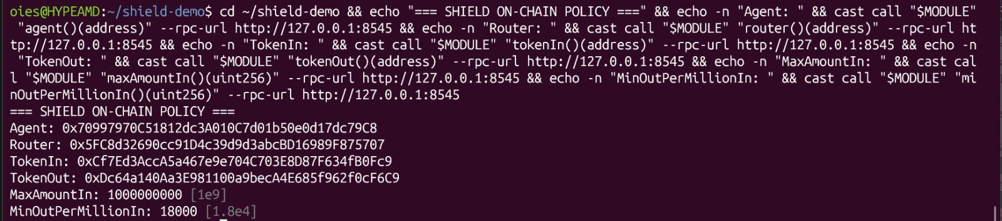
Figure 3. On-chain policy read back from the deployed ShieldSwapModule (agent, router, tokens, maxAmountIn, minOutPerMillionIn).

5. Enforcement Mechanism
The prototype calculates a required minimum output from the policy, records the Safe’s output-token balance before execution, executes the swap through the Safe, and then computes the actual balance delta. If the actual received amount is below the required minimum, the module reverts with OutputTooLow.
uint256 requiredMin =
amountIn * minOutPerMillionIn / 1e6;

uint256 before =
IERC20Min(tokenOut).balanceOf(address(safe));

// execute swap through Safe

uint256 received =
IERC20Min(tokenOut).balanceOf(address(safe)) - before;

if (received < requiredMin)
revert OutputTooLow();

Figure 1 shows the actual implementation. The minimum is computed from the owner’s policy and not from any agent-supplied value. The module approves the router for amountIn, calls the router’s swap function (passing requiredMin as the minimum-output argument), and then resets the approval to 0. The final balance check is performed regardless of whether the router honored that argument, which is the property tested in Case 7.3. Every external action is executed through the Safe via execTransactionFromModule.
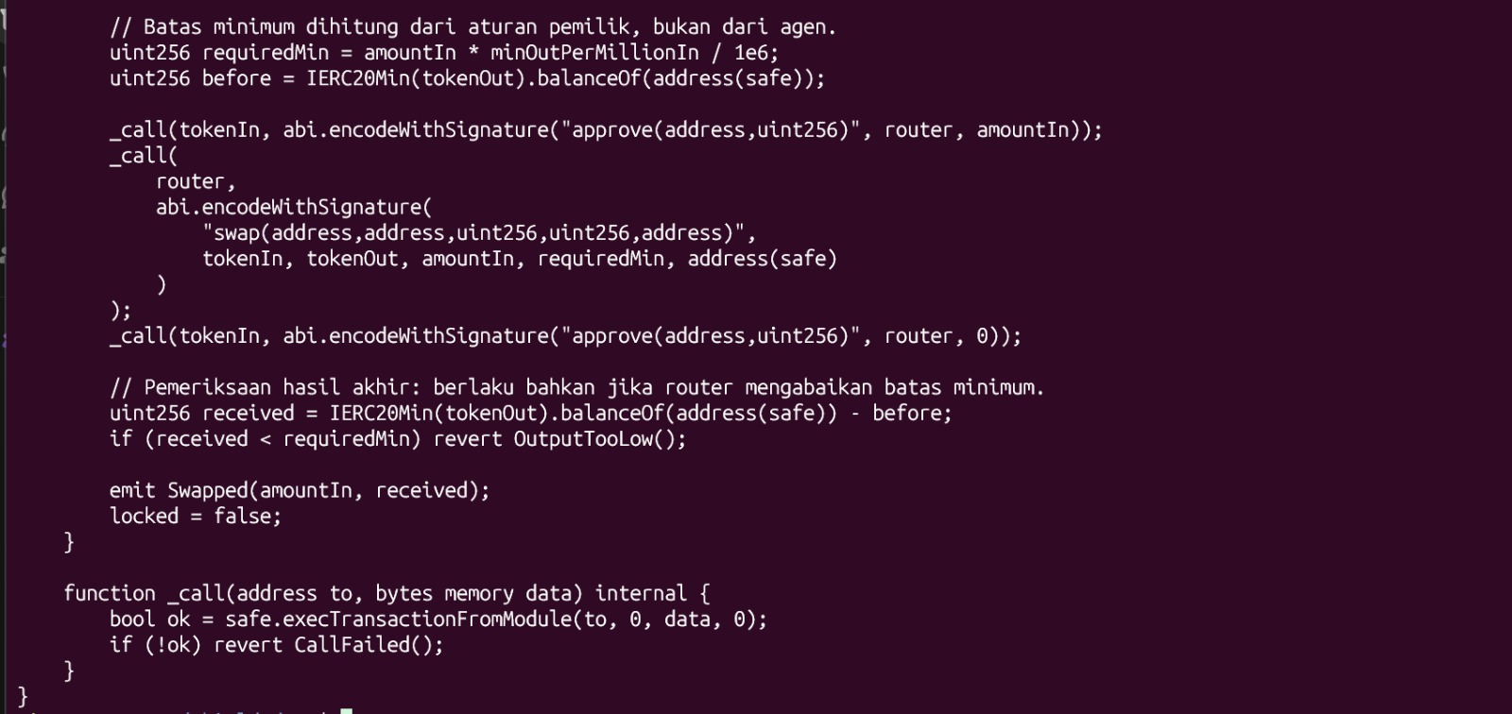
Figure 1. Source-code implementation of deterministic outcome enforcement (ShieldSwapModule.sol): requiredMin, before/after balance calculation, and the OutputTooLow revert.

6. Automated Verification
The prototype test suite was executed with Foundry. The recorded test suite passed five enforcement-related tests: amount limit, expiry, unauthorized agent, insufficient output, and successful compliant swap.
Recorded result: 5 passed; 0 failed; 0 skipped (suite ShieldSwapModuleTest). The complete forge test -vv run covered three suites (ShieldModuleTest 7 tests, DemoTest 8 tests, ShieldSwapModuleTest 5 tests) and finished with 20 passed; 0 failed; 0 skipped.
Test (ShieldSwapModuleTest) | Rule tested | Result
test_RevertWhen_AmountTooHigh | Amount limit | PASS
test_RevertWhen_Expired | Policy expiry | PASS
test_RevertWhen_NotAgent | Unauthorized agent | PASS
test_RevertWhen_OutputTooLow | Insufficient output | PASS
test_SwapSucceedsWhenOutputMeetsMinimum | Compliant swap | PASS

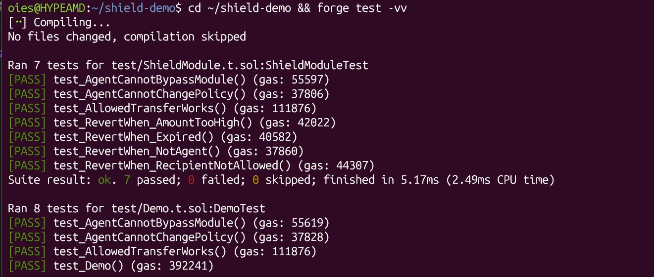
Figure 2a. forge test -vv: start of the run (ShieldModuleTest 7/7 passed; DemoTest results begin).
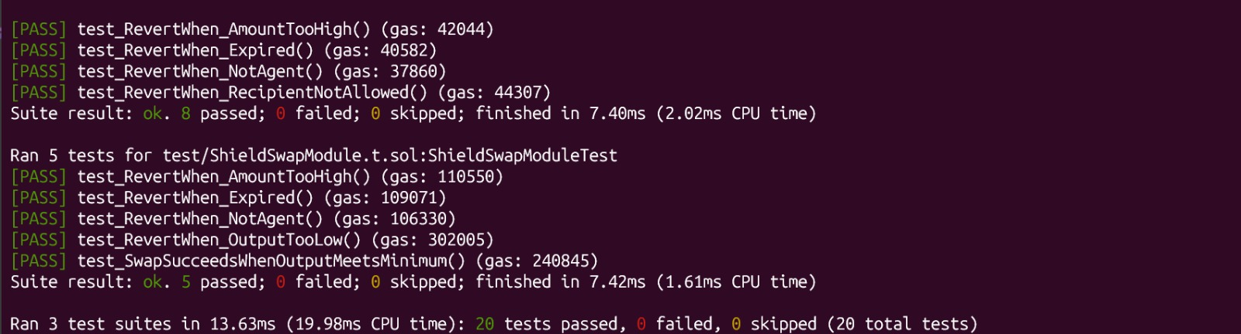
Figure 2b. forge test -vv: the five ShieldSwapModuleTest enforcement tests (5 passed; 0 failed; 0 skipped) and the final result across all suites (20 passed; 0 failed; 0 skipped).

7. Experimental Cases

7.1 Compliant Outcome
Setup: The router was configured so that a 1,000 USDC input produced 20 WBTC, exceeding the 18 WBTC minimum (router rate set to 20,000; Figure 5a).
Result: transaction succeeded. The Safe’s balances moved from 9,000 USDC / 20 WBTC (Figure 6a) to 8,000 USDC / 40 WBTC (Figure 6b), i.e. −1,000 USDC and +20 WBTC. The Swapped event emitted by the module in the receipt (Figure 5b) carries amountIn 0x3b9aca00 (1,000,000,000) and received 0x1312d00 (20,000,000), matching these balance changes.
Evidence: router configuration, valid-swap transaction receipt, and Safe balances before and after the transaction (Figures 5a, 5b, 6a, 6b).
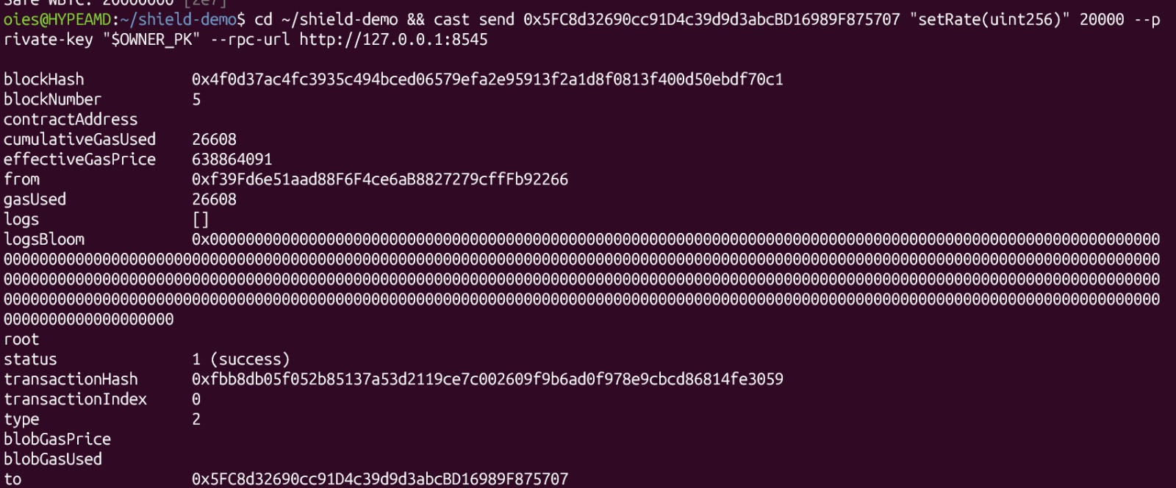
Figure 5a. Router rate set to 20,000 (block 5, status 1) so that 1,000 USDC yields 20 WBTC.
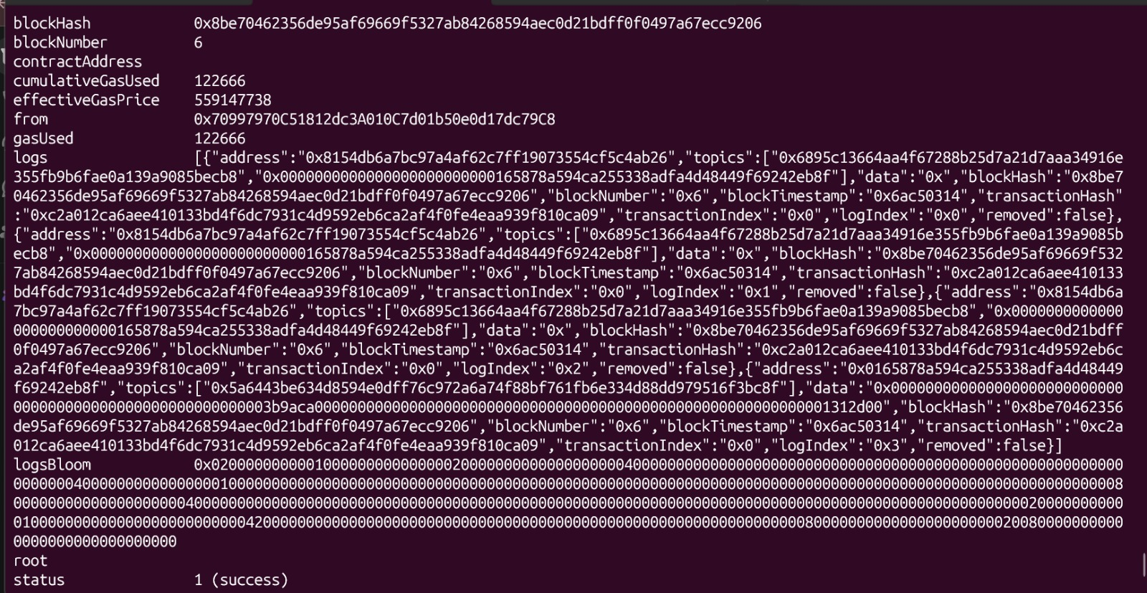
Figure 5b. Valid swap transaction receipt sent by the agent: block 6, status 1 (success), gas used 122,666; logs include the module’s Swapped event.
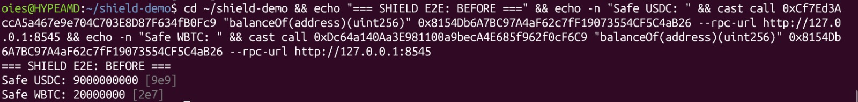
Figure 6a. Safe balances before the compliant swap: 9,000 USDC (9e9) and 20 WBTC (2e7).
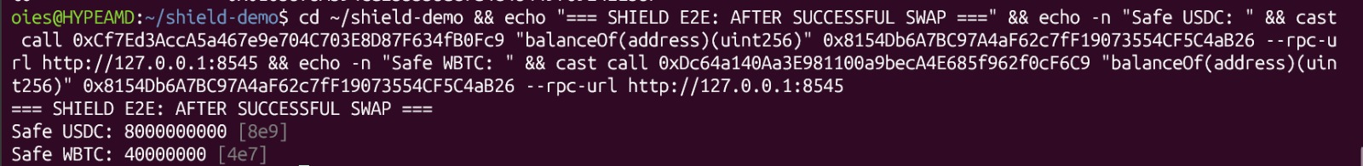
Figure 6b. Safe balances after the compliant swap: 8,000 USDC (8e9) and 40 WBTC (4e7).

7.2 Router-Level Rejection
Setup: The router was configured to produce 17 WBTC while still honoring minOut. The router itself rejected the swap.
Result: transaction failed before SHIELD’s post-execution check could be demonstrated independently.
Evidence: retained as supporting context only (no screenshot is included for this case); it is not presented as proof of SHIELD’s independent outcome enforcement.

7.3 Adversarial Router — SHIELD Enforcement
Setup: The router rate was changed to 17,000 and honorMinOut was disabled. Thus the router was deliberately configured not to enforce the requested minimum output. The SHIELD policy remained at 18 WBTC.
Result: SHIELD reverted with OutputTooLow (custom error selector 0x92ea1119), both when the agent’s swap was submitted with cast send (Figure 8a) and when it was simulated with cast call (Figure 8b).
Evidence: router configuration (Figures 7a and 7b), the failed agent swap showing OutputTooLow (Figures 8a and 8b), and unchanged Safe balances (Figure 9, Section 9).
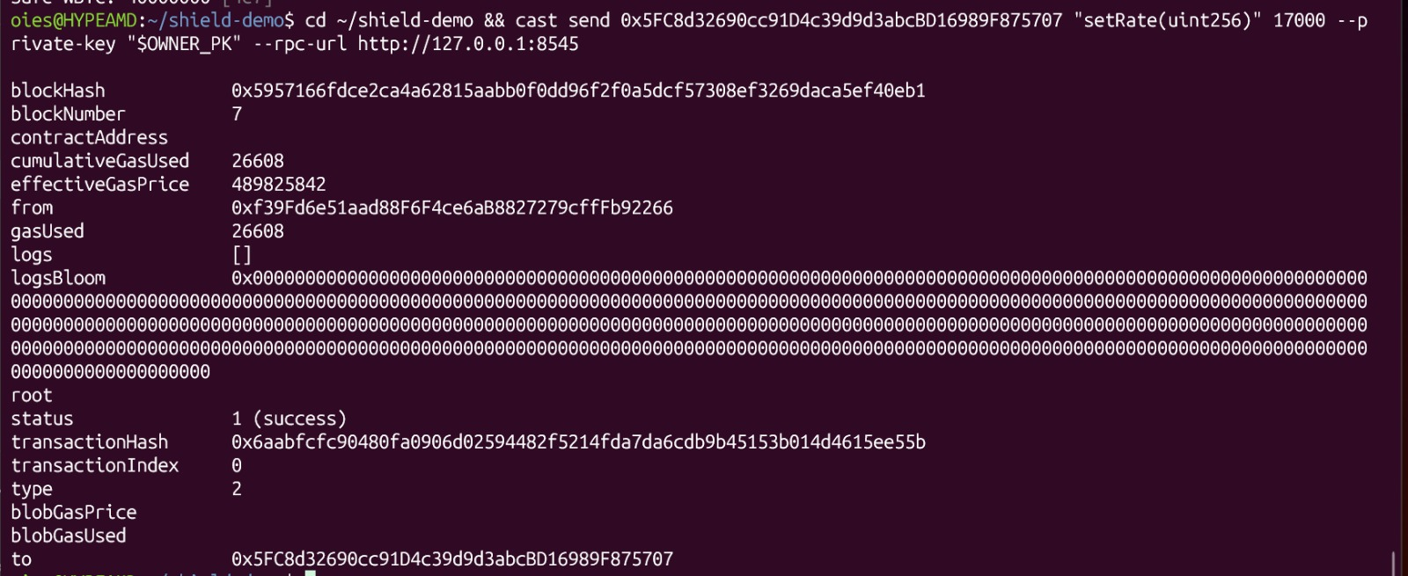
Figure 7a. Router rate set to 17,000 (block 7, status 1).
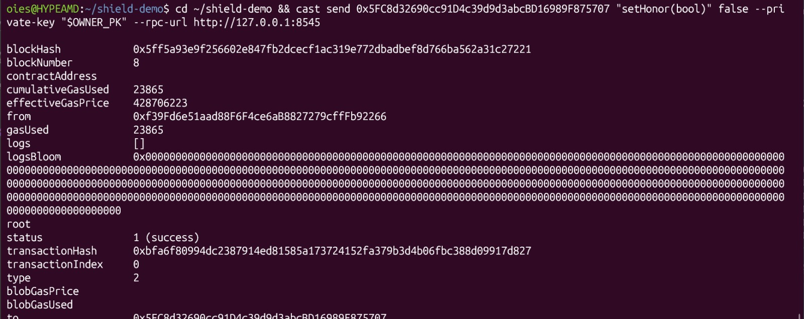
Figure 7b. Router setHonor(false): the router no longer honors minOut (block 8, status 1).
Figure 8a. Agent swap of 1,000 USDC (1000000000) submitted with cast send: rejected with custom error 0x92ea1119 = OutputTooLow.
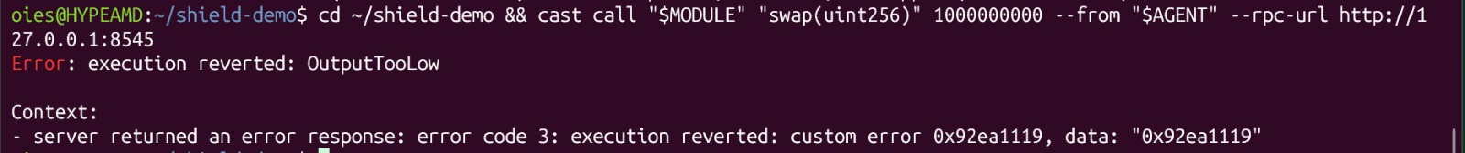
Figure 8b. The same swap simulated with cast call from the agent: execution reverted: OutputTooLow.

7.4 Unauthorized Policy Modification
Setup: The agent attempted to call setPolicy directly, with a maximum input of 2,000 USDC, a minimum output of 0 and a far-future expiry (2000000000, 0, 9999999999) — an attempt to loosen the policy.
Result: call reverted with NotSafe (custom error selector 0x9dc4246e) because setPolicy is restricted by onlySafe.
Evidence: Figure 4.
Figure 4. Agent attempt to call setPolicy rejected with NotSafe (0x9dc4246e).

8. Transaction Evidence
Successful compliant swap (sent by the agent, Figure 5b):
- Transaction: 0xc2a012ca6aee410133bd4f6dc7931c4d9592eb6ca2af4f0fe4eaa939f810ca09
- Block: 6
- Status: 1 (success)
- Gas used: 122666
- Input: 1,000 USDC
- Output: 20 WBTC

Router configuration transactions (sent by the owner):
Step | Transaction hash | Block | Status | Gas used
Router rate = 20,000 (compliant case) | 0xfbb8db05f052b85137a53d2119ce7c002609f9b6ad0f978e9cbcd86814fe3059 | 5 | 1 (success) | 26608
Router rate = 17,000 (adversarial) | 0x6aabfcfc90480fa0906d02594482f5214fda7da6cdb9b45153b014d4615ee55b | 7 | 1 (success) | 26608
Router honorMinOut = false | 0xbfa6f80994dc2387914ed81585a173724152fa379b3d4b06fbc388d09917d827 | 8 | 1 (success) | 23865

The adversarial agent swap itself was rejected during gas estimation / simulation (Figures 8a and 8b), so no transaction hash exists for it.

9. State-Preservation Evidence
After the adversarial swap was rejected, the Safe balances were queried again. The recorded balances were 8,000 USDC and 40 WBTC. These balances were unchanged by the failed adversarial execution (they equal the post-swap balances of Figure 6b), supporting the conclusion that the reverted transaction did not leave the attempted state change committed.
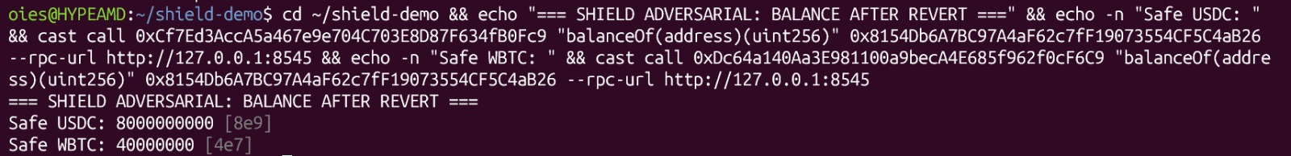
Figure 9. Safe state after SHIELD rejected the adversarial outcome: Safe USDC 8000000000 [8e9], Safe WBTC 40000000 [4e7].

10. Evidence Placement Checklist
Figure | Screenshot | What it proves
Figure 1 | 01_source_code_enforcement.png | Shows requiredMin, before/after balance, OutputTooLow.
Figure 2 | 02_forge_tests.png (2a + 2b) | Shows all PASS results and 5 passed / 0 failed (20 passed in total).
Figure 3 | 03_onchain_policy.png | Shows agent, router, tokens, maxAmountIn and minOutPerMillionIn.
Figure 4 | 06_policy_escalation_rejected.png | Shows agent attempt rejected with NotSafe.
Figure 5 | 04_valid_swap_transaction.png (5a + 5b) | Shows router rate 20,000 and the valid swap’s block, status and gas.
Figure 6 | 05_valid_swap_balance_after.png (6a + 6b) | Shows Safe balance change after compliant swap (before and after).
Figure 7 | 07_router_rate_17000.png + 08_router_honor_minout_false.png | Shows rate 17,000 and router ignoring minOut.
Figure 8 | 09_adversarial_output_too_low.png (8a + 8b) | Shows OutputTooLow/custom error.
Figure 9 | 10_balance_unchanged_after_revert.png | Shows unchanged Safe balances.

11. Experimental Results Summary
Case | Policy / Condition | Observed Result | Interpretation
B4.1 | 1,000 USDC → 20 WBTC; minimum 18 | Success | Compliant outcome accepted
B4.2 | Router produces 17; router honors minOut | Revert | Router rejects; not independent SHIELD proof
B4.3 | Router produces 17; router ignores minOut | OutputTooLow | SHIELD rejects based on actual received output
Policy escalation | Agent calls setPolicy | NotSafe | Agent cannot change policy

12. Interpretation
The strongest result is B4.3. In that case, the downstream router was deliberately configured not to enforce the minimum-output parameter. The SHIELD module independently measured the Safe’s output-token balance delta and reverted when the observed result was below the policy threshold. This supports the feasibility of an outcome-enforcement layer that is not solely dependent on the downstream protocol honoring a requested slippage bound.
The policy-escalation test additionally shows that the agent execution authority is separated from policy-setting authority in the prototype: policy configuration is restricted to the Safe.

13. Limitations
- The experiment uses Anvil rather than a public testnet or mainnet.
- MockRouter and DemoToken are intentionally simplified demonstration contracts and are not production implementations.
- The demo does not establish resistance to MEV, oracle manipulation, proxy upgrades, fee-on-transfer tokens, rebasing tokens, or complex protocol behavior.
- The enforcement contract has not undergone an external security audit.
- The experiment evaluates a deterministic minimum-output policy only; it does not validate arbitrary natural-language intent or portfolio drawdown guarantees.
- The adversarial swap was observed being rejected at the gas-estimation / simulation stage (cast send and cast call); a transaction force-broadcast with a manual gas limit and mined as a reverted transaction was not recorded.
- The observed result demonstrates feasibility under tested conditions, not comprehensive security or production readiness.

14. Reproducibility and Evidence Archive
The screenshots should be archived together with the exact source code commit, Foundry test files, deployment script, contract addresses, terminal commands, and transaction hashes. Screenshots are presentation evidence; the source code and reproducible test commands are the primary technical evidence.
- evidence/B4-onchain-enforcement/01_source_code_enforcement.png
- evidence/B4-onchain-enforcement/02_forge_tests.png (2a: start of run, 2b: ShieldSwapModuleTest and totals)
- evidence/B4-onchain-enforcement/03_onchain_policy.png
- evidence/B4-onchain-enforcement/04_valid_swap_transaction.png (5b) and 04a_router_rate_20000.png (5a)
- evidence/B4-onchain-enforcement/05_valid_swap_balance_after.png (6b) and 05a_valid_swap_balance_before.png (6a)
- evidence/B4-onchain-enforcement/06_policy_escalation_rejected.png
- evidence/B4-onchain-enforcement/07_router_rate_17000.png
- evidence/B4-onchain-enforcement/08_router_honor_minout_false.png
- evidence/B4-onchain-enforcement/09_adversarial_output_too_low.png (8a: cast send) and 09a_adversarial_cast_call.png (8b: cast call)
- evidence/B4-onchain-enforcement/10_balance_unchanged_after_revert.png

15. Proposed Thesis Conclusion for This Experiment
Under the tested local EVM conditions, the SHIELD prototype demonstrated deterministic on-chain enforcement of a minimum-output policy for an agent-executed swap. A compliant outcome of 20 WBTC for 1,000 USDC was accepted under an 18 WBTC minimum. In the adversarial configuration, the router returned 17 WBTC while ignoring the requested minimum-output parameter; SHIELD detected the actual output below policy and reverted with OutputTooLow. The Safe balances remained unchanged after the rejected execution. These results support the technical feasibility of the proposed outcome-policy enforcement mechanism, while the stated limitations prevent generalizing the result to production security or arbitrary protocols.

Appendix A — Contract Addresses
Role | Address
OWNER | 0xf39Fd6e51aad88F6F4ce6aB8827279cffFb92266
AGENT | 0x70997970C51812dc3A010C7d01b50e0d17dc79C8
SAFE | 0x8154Db6A7BC97A4aF62c7fF19073554CF5C4aB26
MODULE | 0x0165878A594ca255338adfa4d48449f69242Eb8F
USDC | 0xCf7Ed3AccA5a467e9e704C703E8D87F634fB0Fc9
WBTC | 0xDc64a140Aa3E981100a9becA4E685f962f0cF6C9
ROUTER | 0x5FC8d32690cc91D4c39d9d3abcBD16989F875707

